Assessment Three Portfolio

Alice Hannah Roberts

BCDE211

10 June 2019

Contents

Introduction 3

Overview of Processes https://static1.squarespace.com/static/57c6b79629687fde090a0fdd/t/5b19b2f2aa4a99e99b26b6bb/1528410876119/dschool_bootleg_deck_2018_final_sm+%282%29.pdf
Class Diagram http://agilemodeling.com/artifacts/classDiagram.htm, http://agilemodeling.com/style/classDiagram.htm

One ~ Empathise

Introduction
The goal of my project is designing a cycling app using JavaScript, studying users in Christchurch in particular. The group I am focusing on that would most benefit is the cyclists that cycle around the area.
It has to be useful to this group in a way that they would want to use it while cycling, before, during and after. It needs necessary features that makes it desirable for a cyclist to want to use it to track their cycling statistics.
Using the design thinking process we will explore different options in design thinking, so we can challenge our assumptions and explore many possible best solutions for this project. This will start with refining our goal as with the Agile mindset.
Our goal is to create a cycling app that makes the cyclists using it want to use it because it’s useful to them, figuring out what their thoughts and needs are, is the next steps through the empathize and define stages.
It will be achieved by first making a good user experience and desirability through understanding these cyclists.

Observe – Photo Biased Study
To observe in detail and to put me in the mindset and situation of what it’s like using one of these apps while on your bike, I got my partner who has been a biker and mountain biker for his whole life, to have a go at trying out a cycling app: Cycling - Bike Tracker, Google Play Store, and recorded what he thought about it.
This also has the added benefit of having a beginner biased mindset have a look at a cycling app for the first time, as this is the first cycling app he and I have tried.
I asked him to tell me what his initial thoughts were on the app, and try and think about the app as you would naturally. I asked him to apply the beginner’s mindset technique to question everything and be truly curious.
The pre-study setup was on an android device, and involved installing the app from google play store and opening it from the home screen.
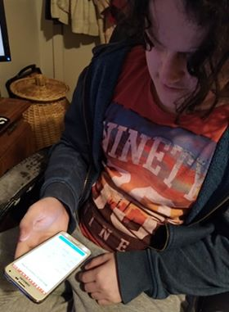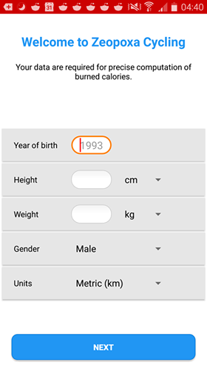
The first step prompted was to create an account or user, which involved entering details about yourself. He asked;
“What if you’re not wanting to provide details about yourself, some people might not like that”.
I take that these would be used to make calculations to do with making statistics to do with fitness. As this might make people feel uncomfortable, a good tactic to communicate better with the user is for it to tell the user why the information is being gathered, presenting the benefits of using the apps features that use these statistics.

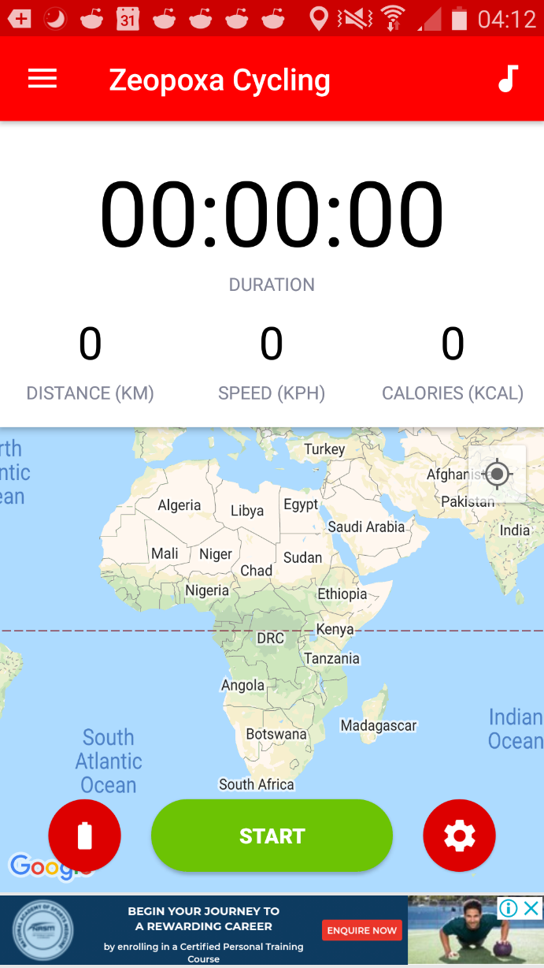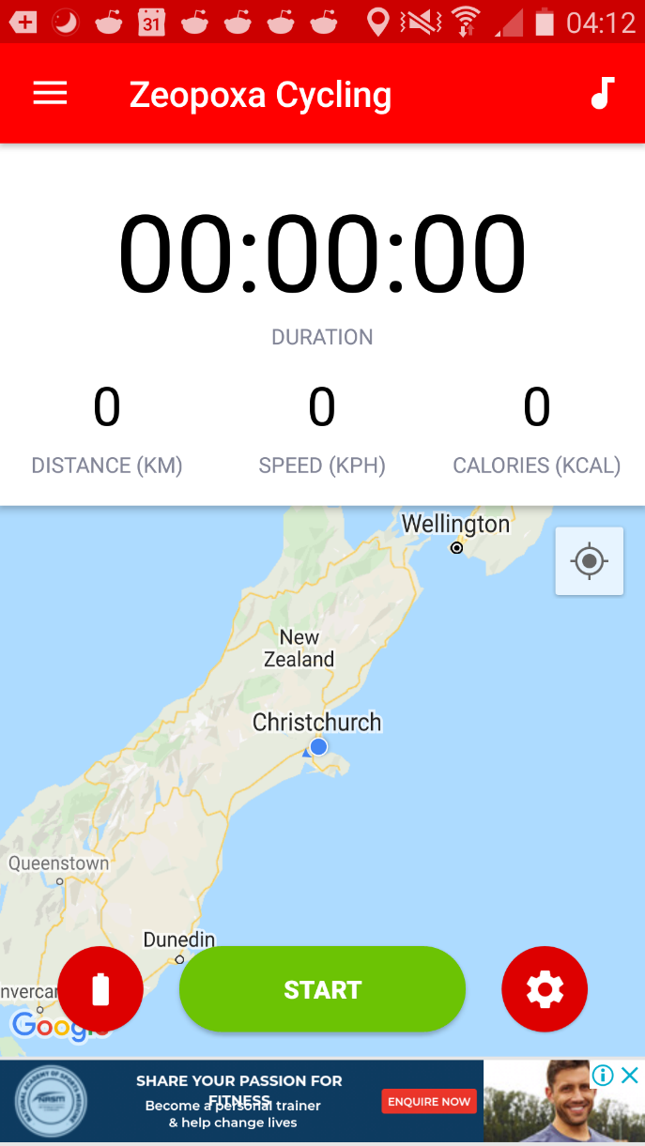
The initial screen showed the world map. He was able to enable location services and the map showed New Zealand.
“Why is it not showing my current location? Shouldn’t it detect that automatically?”
This is interesting because some people who don’t know as much about mobiles might not be able to identify the issue. And therefore, be unable to use the app properly and be frustrated and confused. The app needed to better communicate the settings and permissions that were required on start-up.

“It’s not very zoomed in, I’d like it to auto zoom in better since that would be annoying while cycling to fiddle with it, and it might even require two hands.”
Fiddling with zooming in and out of maps can be slow on mobile and annoying too.
He started a new ride and stopped it after with the same problem.
“It isn’t showing the ride, like an image of the route”.

The app had four categories of information for the ride. An overview and a statistical graph for speed elevation and duration:
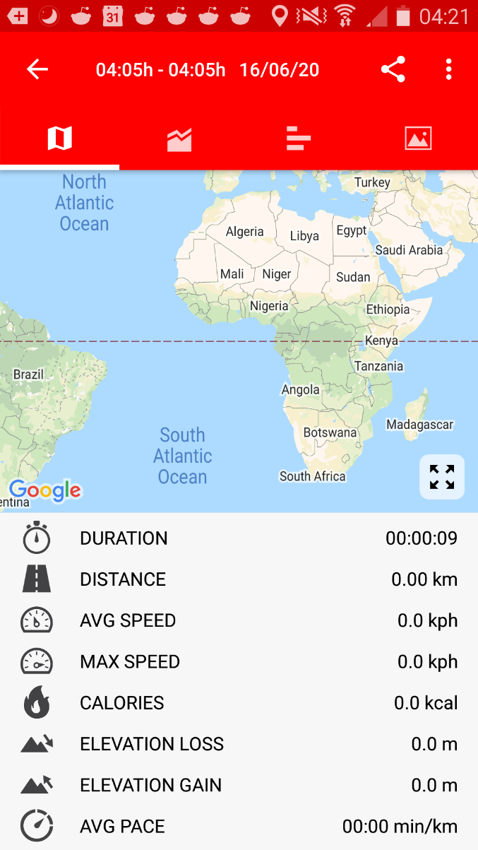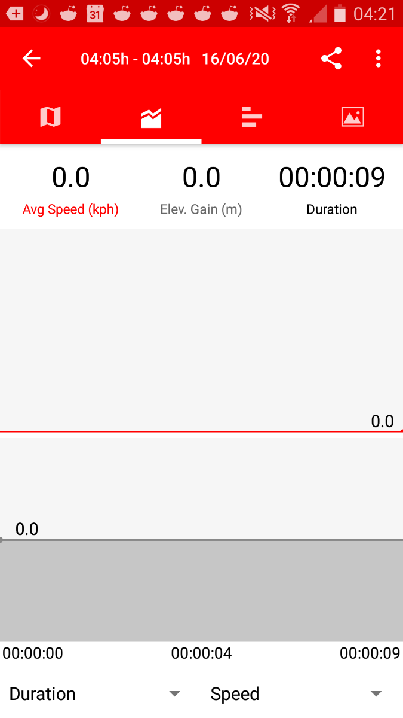
“I feel like this overview has the right information for what you need to see easily.”
My own thoughts on this was that the statistical graph might be useful, but I think it doesn’t really teach the user much, though you could use it to compare two routes, but it’s poor and frustrating user experience to have to do that yourself. It would be useful to have a “compare routes” function.

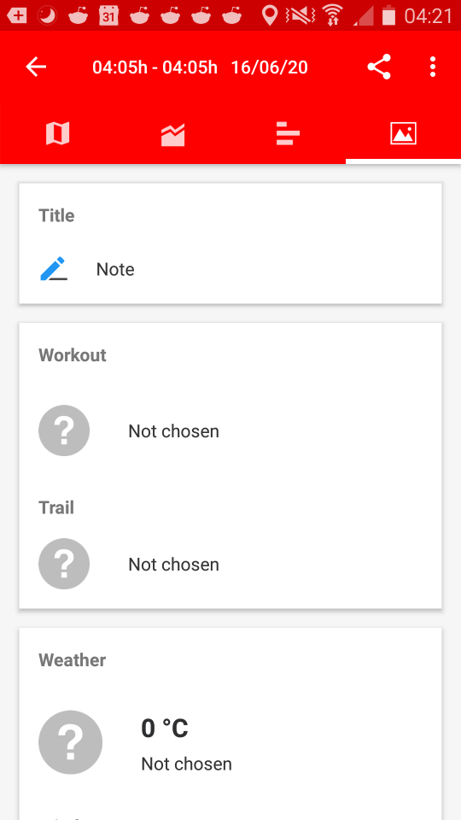
It also showed a table of stats, and personal notes.
“I like the notes, this is a useful future, but the table just shows information that it’s already shown”.
Displaying unnecessary information just clutters the screen, making it harder to read for the user.
I encouraged him to explore the app menu options:
“I like the BMI calculator, I feel like someone who is interested in fitness would like that to be in-app. I also like the different things that show other rider’s statistics. It would be cool if they could be connected to people you know through Facebook or something.”
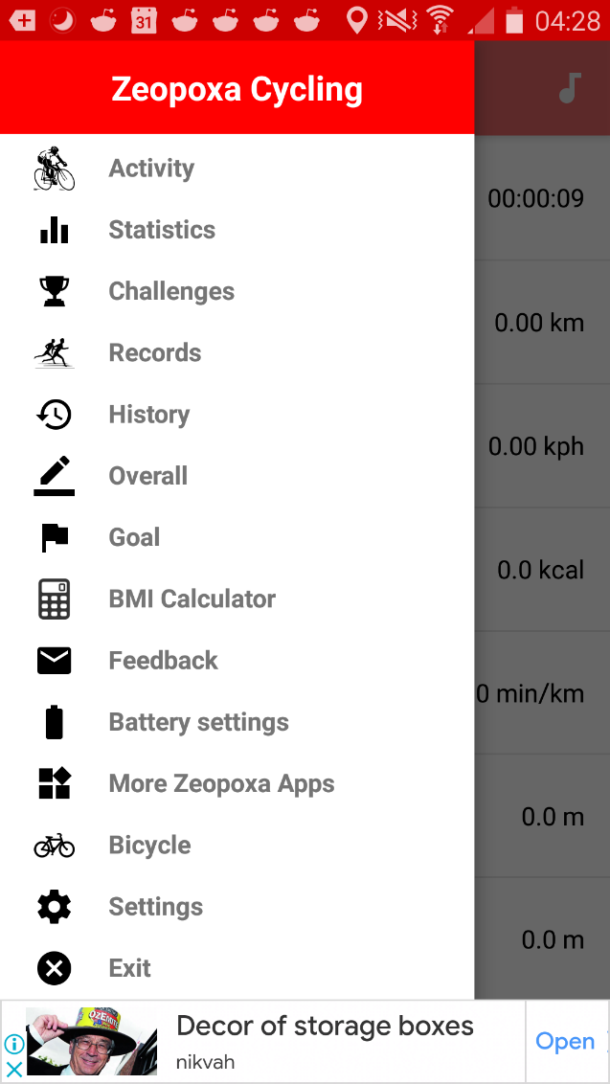
Connecting to Facebook to find friends could save users a lot of manual search hassle, but this feature neds to be options for people concerned with doing this.
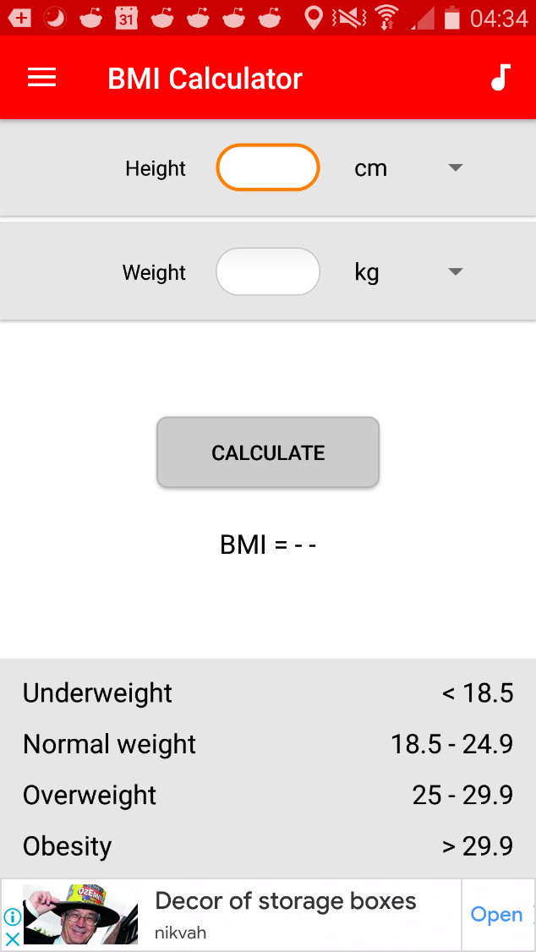

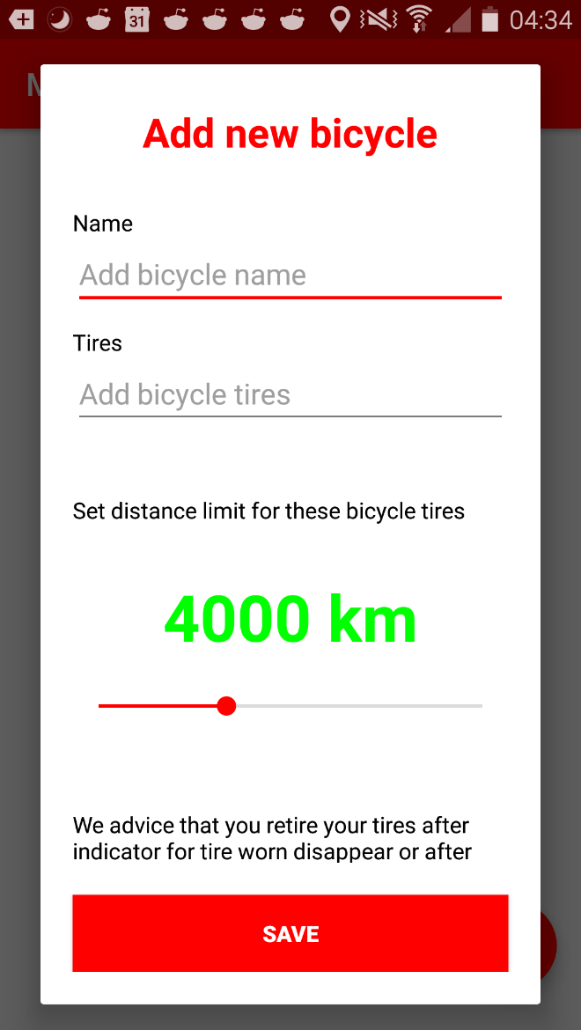
“The challenges are cool to, it makes cycling more fun for people who don’t set goals.”
The ability to keep track of goals for the user would make it exciting, rewarding and fun. They want to feel good and see their progress.
“The ability to keep track of your bicycle and keep track of how much you used your tires is kind of useful, but I feel like not necessary since most people only replace them after visibly checking them, they usually keep track of when they last replaced them in their head.”
One thing I personally observed is that a lot of the menus require you to use the phones back button, that might confuse some people who are used to using the GUI.

Engage – User Group Interviews

For this project we conducted interviews with cyclists from Christchurch. A brainstorm best fit mapping the different areas that we could cover with the interview questions.
Each question is not always written in an open-ended style in this brainstorm to keep it succinct. However, I kept this in mind while interviewing each participant.
This was a semi-structured interview, not all questions are applicable or were not asked of every participant, and new topic were explored.

Interview Questions

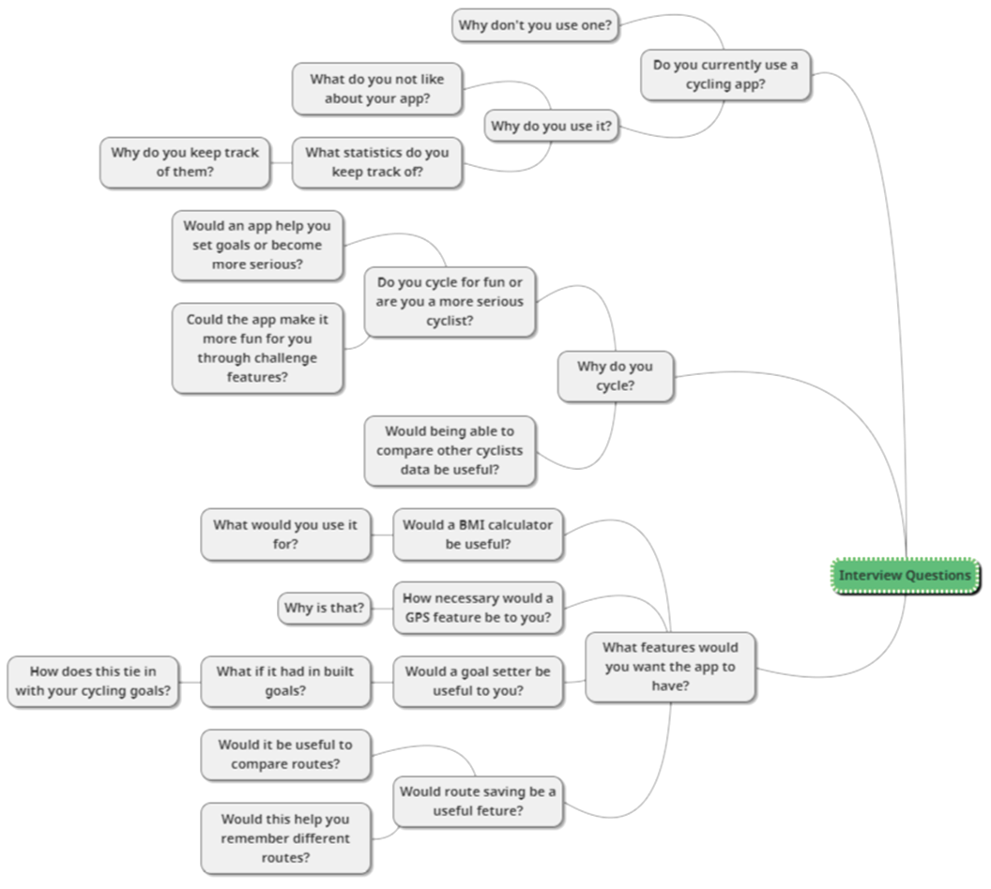
Here are some of the responses I got from each participant that I got around to asking, these snippets offered new insight to what they would want from their cycling app.

Participant One:
“Do you currently use a cycling app?”
“Yes, I do, I use Stravia. It’s quite popular.”
“What do you like about it?”
“It’s very detailed, it does everything.”
“Would you say it’s overly complex?”
“No, I think it’s well laid out, but I guess for a less serious biker it might be a bit much. It needs to have an easy to use UI, big buttons so it’s easy to use while outdoors.”

Participant Two:
“Do you currently use a cycling app?”
“No, I currently don’t. I’m not an intense cyclist, I mainly just get on my bike and go.”
“So, you don’t usually like to set goals? Why is that?”
“No, I don’t really, I’m not the kind of person to enjoy cycling like that, I think of it more as a hobby. I think setting goals would make it more like a chore.”
“What do you think of the idea of fun challenges to participate in in the app?“
“Yes! That would be interesting.”
“So, we could make it more gamified?”
“Yes exactly.”

Participant Three:
“What do you use your app for?”
“I like to use it for tracking my routes, and how much I’ve cycled each week.”
“Would it be useful to save your routes?”
“Yes, I’d like that.”
“Being able to do so would help you remember routes you’ve previously been on, like get ideas for previous routes?”
“Yes, that would be useful.”
“How would a feature be that would allow you to compare routes, or have a feature that would allow you to see similar routes automatically to give you ideas?”
“Yes, that would be really useful, to give ideas of routes that are a similar length. Automatically calculating distance is a must for the app.”

Participant Four:
“What don’t you like about using your app? “
“I don’t like unnecessary notifications with it.”
“This would be bad since it interrupts you while cycling?”
“Yes, I don’t like to ever have to pull it out of my pocket while cycling and look at it.”
“Would a voice readout feature be useful while your cycling. It could tell you how long you’ve cycled for or how far you’ve gone.”
“Yes, that would be very interesting.”
“Just would have to know how to implement it.”

Immerse – Journey Map

This journey map explores what a cyclist, Craig, would do with the app in a real-world scenario, and helps us understand the cyclist’s perspective of what it would be like for them.
The goal for this user in this case would be to use the app to keep track of how long they’ve cycled for, and when they’ve hit the 8km mark. This is to participate in an 8km race.
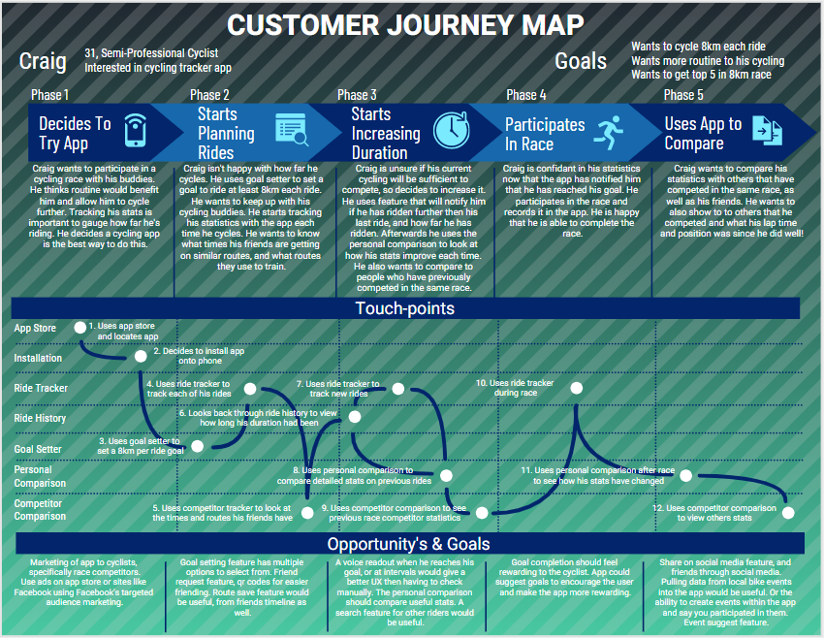

Two ~ Define

Synthesise - User Needs

Why / How Diagram
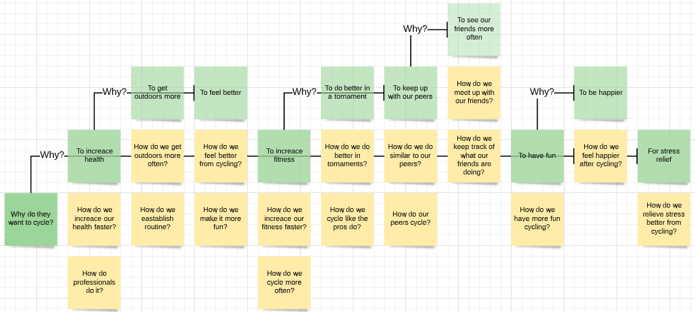
From our studies we want to explore the different reasons why each user wants to cycle. This is to explore what problems are needed to be addressed by the problem statements.
  - Each why statement is expanded using why statements upwards and right, and each point is then expanded using how statements downwards, asking more direct questions further down.

Affinity Diagram
All the ideas that were expressed by empathising with our cyclists were here synthesised together to find groupings of ideas. While going through this process I realised that they could be grouped in two ways:
We could group them by topic, for instance UX or goals. Or we could order them on a spectrum of the cyclist’s seriousness, similar to a 2x2 matrix technique. The more goal orientated, serious and competitive, versus the more hobbyist personalities.
Throughout interviewing I noticed certain groupings of ideas were more common to be found together in one participant where they aligned with these two goals and aspirations. Some of the ideas expressed on the chart related to both, and these were grouped towards the middle of the chart.
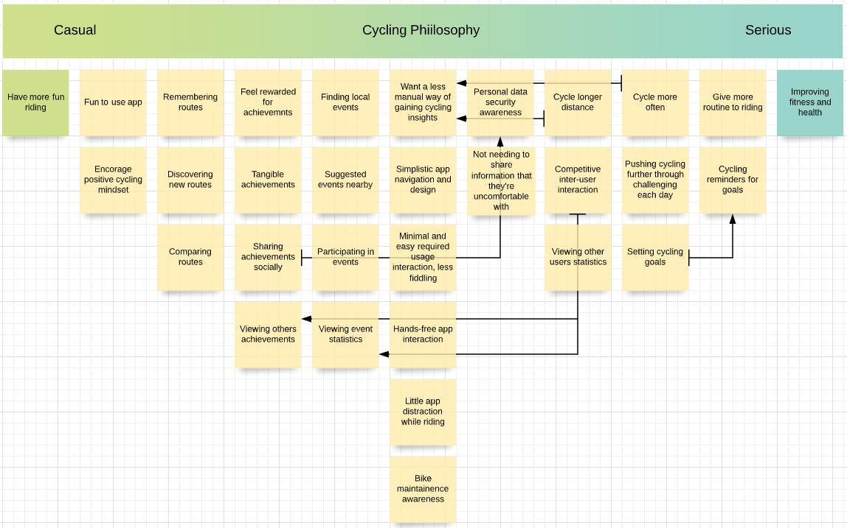
  - The groups started with a main idea, then were expanded upon downwards getting more complex. Some connections were discovered between different groups, that were prerequisites or similar.

User Profile - Research
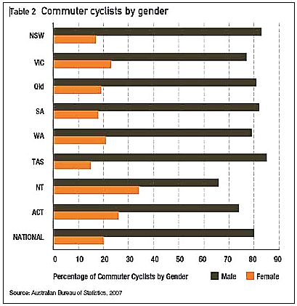
This figure shows the comparison of male and female cyclists throughout the states of Australia. Taken by the Australian Burau of Statistics, 2007. (Cycle Helmets, n.d.)
Our users that were studies in our interviews were all from Christchurch. They were a range from casual, semi-professional to professional. All of our subjects were male and in their middle ages. This is not indicative to all users that will use this app.
The nature of a google app store app is that users from all over the world will use it. Our users will want the app to work wherever they go.
Our demographic is not gender specific in cycling both genders participate, however less women participate then men. (Perry, 2017), (AlixStredwick, 2017). So, there is likely to be less women wanting to use a cycling app a then men, and we can take this into consideration

Problem Statement - Point of Views

We identified three main goals for each cyclist: improving health, increasing fitness, and to have more fun cycling, and took the problems each might face in achieving them.

Our cyclist has the problem that they can’t be healthier by getting the recommended amount of daily exercise when they lack routine and time. This makes them feel unfit and unwell. Our solution should deliver an easier way to maintain their routine and make it easier and more fun to get to the correct amount of exercise.

Our cyclist has the problem that they aren’t at their desired fitness level from their cycling because they aren’t cycling enough or fast enough. This makes them feel inadequate. Our solution should deliver a way for them to encourage them to cycle more, and for longer. It should have a way of keeping track of their stats, how they’re improving and reward them for doing so.

Our cyclist has the problem that they aren’t having as much fun as they’d like to because they need more challenges for their cycling, or they need to cycle with their friends more. This makes them feel like cycling is a chore. Our solution should deliver fun challenges and make it easier to cycle with their friends.

Three ~ Ideate

Going Wide

We want to challenge our habitual ideas or ways of thinking with new innovations by using a brainstorm for each of our three problem statements. Each brainstorm is still kept in mind of its origin from each problem statement.
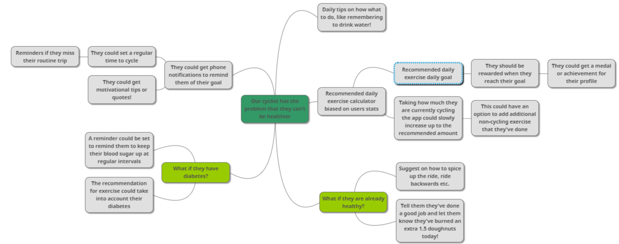
Constraints were suggested to help promote more lateral thinking while brainstorming by the use of ‘what if?’ statements.
  - For our first cyclist that is concerned with their health.

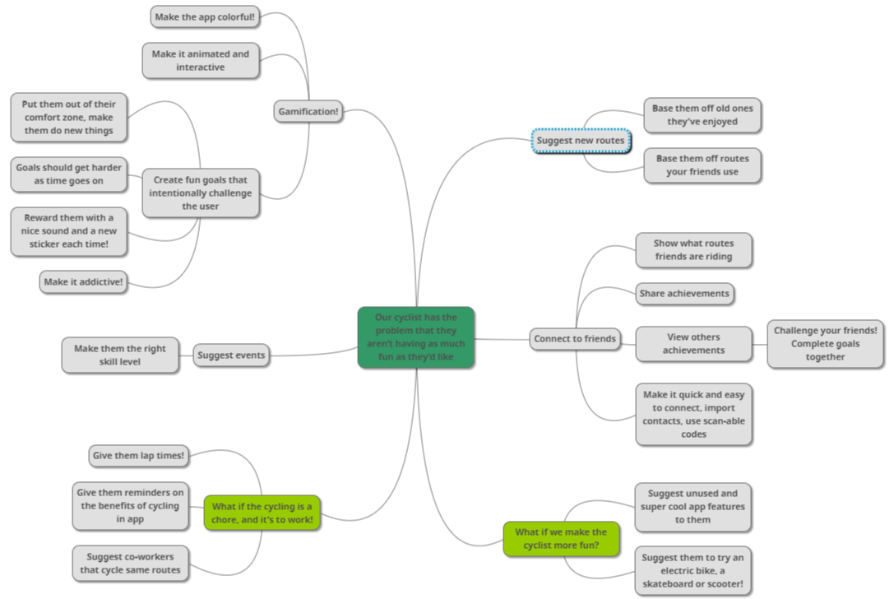
  - For our second cyclist that is concerned with their level of fitness.
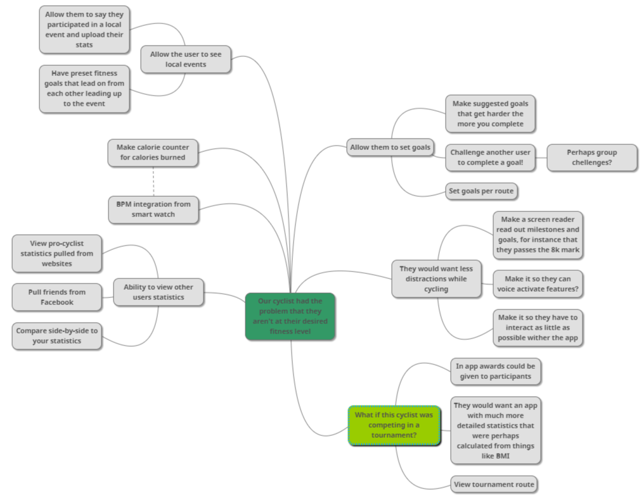
  - For our third cyclist that just wants to have fun.

Focus

To narrow down the bold from the insane we’ll use the four categories to sort these ideas to help choose what to carry on to the prototype stage. The rows are coloured to separate different groups of similar ideas.
Most rational | Most delightful | Darling | Longshot
 | Suggested cycling tips
 | Motivational tips, cycling benefits and other extra tips
Create goals
 | Recommended new goals or achievements like quests
Make the goals unusual and new
Make each goal completed rewarding with sound etc
 | Regular cycle time setter and reminder
 |  |  | Challenge another user to goal
 |  |  | Do group challenges to complete goals
 | Getting awards for completing goals
 |  | Share achievements on social media
 |  |  | Recommended daily exercise calculator biased on stats
 |  |  | Plan that helps them slowly increase to the recommended daily exercise goal
 |  |  | Letting them know how many calories over their goal they’ve burned today
 |  |  | Diabetes functionality for recommended daily exercise and glucose reminders
 |  | Show local events
 |  | Recommend local events
 |  |  | Recommend events biased on skill level
 |  | Allow users to participate in events
 |  |  | Allow users to upload their stats from their event stats
 |  |  | Plans that help train leading up to events
 |  | View tournament or event route
 | BMI calculator
 |  |  | BPM from smart watch
Calorie calculator
 | View other users, their stats and achievements
 |  |  | Find friends through connecting to Facebook
 |  | Side by side comparison between their stats and yours
 |  |  | See where they’ve been cycling
 |  |  | Use scannable codes to quickly add friends
 |  |  | Have pro-cyclist statistics in app
View routes
 | Save routes
 |  | Compare routes
 |  |  | Get suggested similar routes from your own ones
 |  |  | Get suggested routes from your friends’ routes
 |  | Have easily viewable lap times for routes
 | Suggest unused app features through suggestions
 |  |  | Screen reader
Minimal amount of having to interact with the app while cycling
 |  |  | Voice activation features
Make the app colourful
 | Make it interactive and animated

Ideas

These ideas we need to keep in mind in general while designing our app. These have been shown to benefit the types of users using our app, while meeting the level of importance.
User Experience: For good user experience some issues were identified while studying a similar mobile biased cycling app, and found important for the types of users that will be using our app.
Having a large easy to use UI for an app allows the user to use it easier with one hand and on the move.
Not all features are applicable. There are some base features that are needed by most users, and these should be easily accessible. Too many menu items and too many complex UI elements would be detrimental to features for more extreme users should be kept in submenus
Reducing the amount of effort and time the user had to spend on using the app is important in general. Any auto zoom features should be correctly implemented in a mobile map app.
An important thing to note is keeping the flow of the UI navigation simple, and not too deep or complex is important for the user, keeping clear movement through different areas of the app through clear labelling and back buttons.
User Group: Our users will more likely be men then women, therefore we can tailor certain features to appeal more to men. This could be colour choice, icons etc.
Personal Information: While gathering users’ data it’s important to keep in mind that it’s up to you to secure that data. Their personal data should be handled with care, and the user is not required to enter more then they wish to give. This includes entering personal statistics, and importing Facebook friends or connecting to Facebook.
Telling the user why we are gathering their information is an important step to let them know why, letting them know what we will use it for, and also telling them what we are allowed to do with it.
The user needs to be shown what permissions the app will need in order to best function, to reduce misunderstandings and problems that will leave them frustrated.
Gamification: An important aspect to making a fun UX is to make the app enjoyable and rewarding, making it more desirable to use. Doing this through making the user want to cycle more at the same time.

Four ~ Prototype

Wireframe

The feasibility of these ideas will be explored through prototyping testing physically and to find out what our users really want.
A wireframe is the best way to plan out how the interface will look throughout the app.
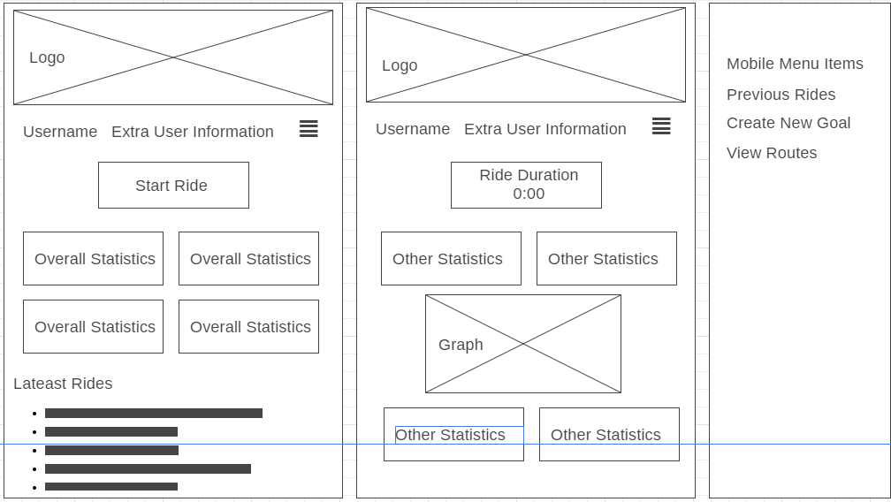
I then asked my family to have a look at the pages and tell me what they thought of them, here are some of their ideas in quotes. And some of mine I gathered from their reactions.

Homepage
“Having a recognisable logo banner on the homepage (shown on left) would be the best way to show the apps brand.”
This could perhaps be removed on pages except for the homepage if more screen real-estate is required, as making the user have to scroll should be avoided I believe to improve usability.
“There could be other things added to the mobile menu”.
“The username and extra user info should be displayed on every page.”
“The start ride option should be on the homepage since this is the main function of the app.”
Overall statistics can include at a glance how many total hours the cyclist has cycled for instance, or how many calories they burned.
Latest rides should show in chronological order, as it is most likely the user will want to access their latest rides most often.

Ongoing Ride Page
The ongoing ride page shows for the user what the current duration is, as well as other statistics.
“A graph could be useful to display data is a more useful way. “

Desktop Users
Desktop users will have more screen real-estate, and therefore I want to take advantage of that to:
- Make the mobile menu easier to access
- Use more space to display other statistics
I moved the navigation to the side so that it will be more viewable as you scroll, and have made it so that the overall statistics are larger.
“It would be nice to have a navigation that scrolls with you.”
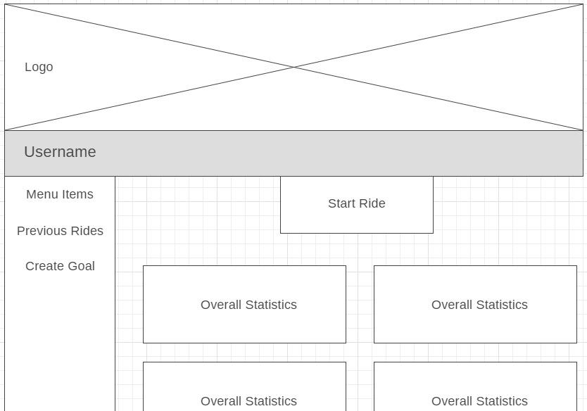

Extra Functions

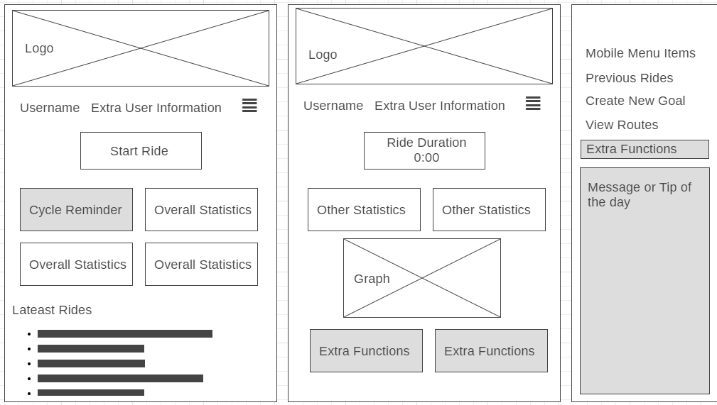
Some extra functions could be implemented, so some extra thought was put into where they’d show and how they’d work from my family’s feedback.
Extra functions can be accessed at the bottom of the mobile menu. This was done since extra functions were determined to be less important to the user and will therefore be accessed less frequently.
All other areas that can be extended or added to are highlighted in grey. For instance, adding a message of the day in the mobile menu, so it can be easily viewed, without taking up screen space constantly.
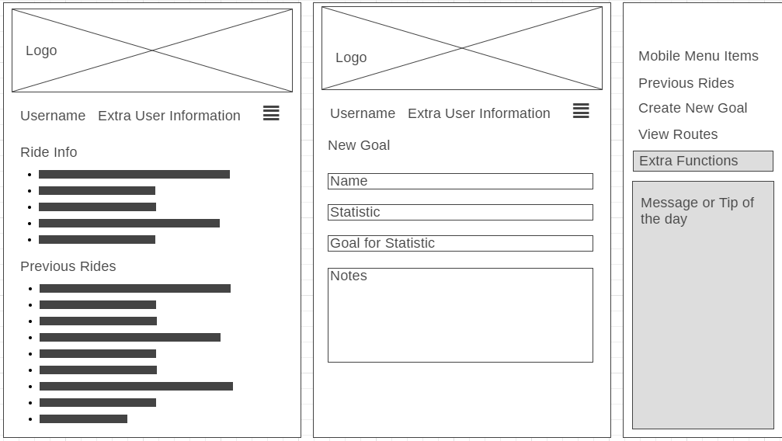
Here is how some of these extra functions will look. On the left is viewing extra ride information, on the right is creating a new goal.

User Group – Research and Prototype

For our user group, I want to focus on what our demographic likes best. In research, there are clear preferences towards certain colours.
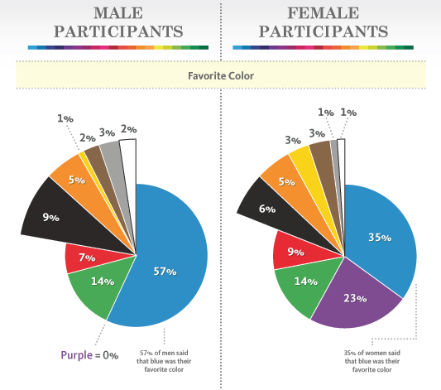
For both men and women blue is overwhelmingly popular. For men their second favourite is green.
A mix of blue-green was chosen by participants when they had the ability to choose their favourite for themselves from a varied colour palate (Knapton, 2017).
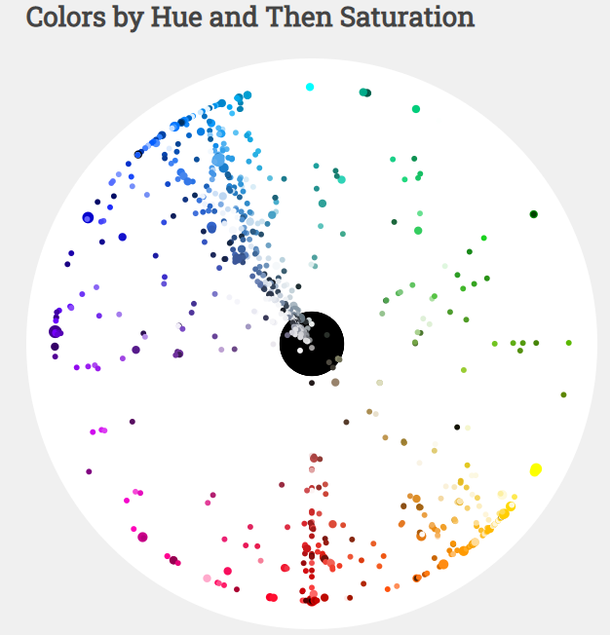
Blue and green are associated with nature being both the colour of the sky and plants, this makes it appropriate for a cycling app. (Color Phycology, n.d.)
This is reflected in the chart for the most popular colours used in web design for the most popular websites in 2016.
  - Pie charts from a study by University of Maryland sociologist Philip Cohen, n = 2,000 (Wolchover, 2012)

  - Scatter plot from study in 2016 (Herbert, 2016)

Here is three drafts of what some example colours would look like on the webpage.

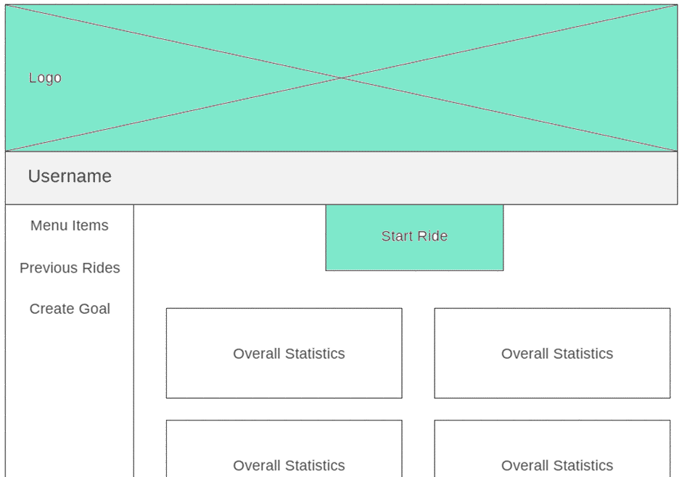
Option One
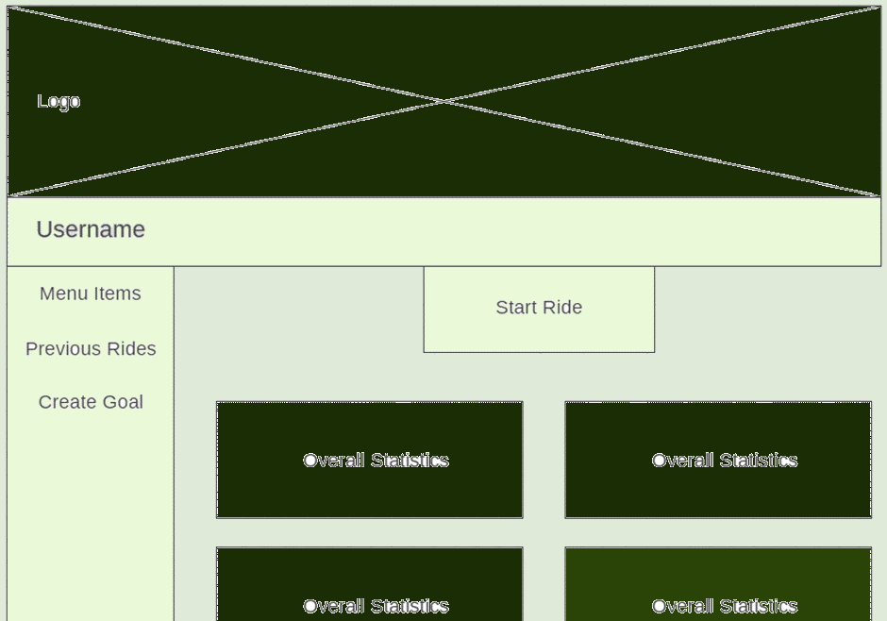
Option Two
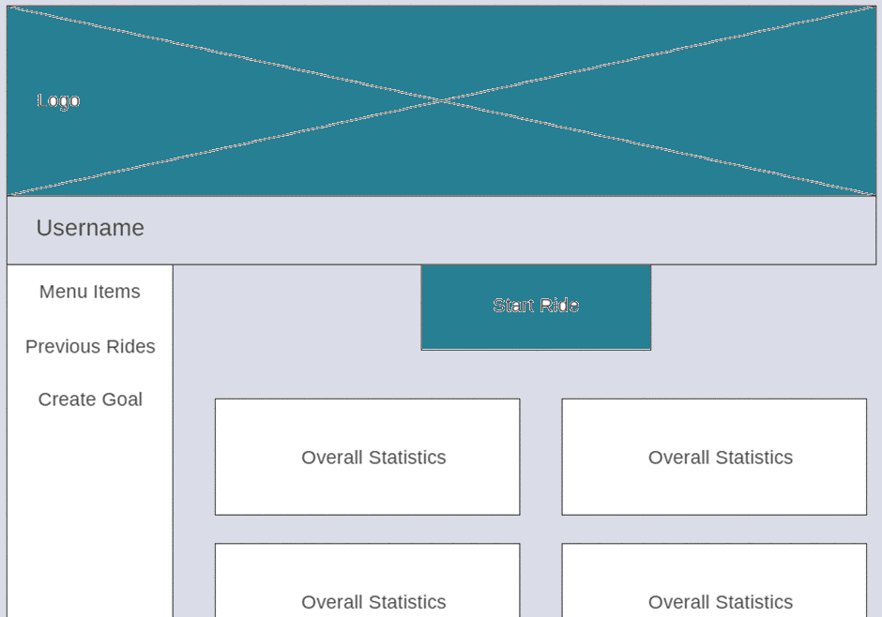

I then asked my family to choose what ones they liked best and why.

Two choose option one. They cited that
“option one is simpler and cleaner, lighter in color.”

Three choose option three. They cited “I like this one since it’s darker” and “I like the shade of blue”. They also said they’d perhaps like more contrast with black added to make it better.

I then came up with a new design that was more appealing to everyone, option 4.
Option Three

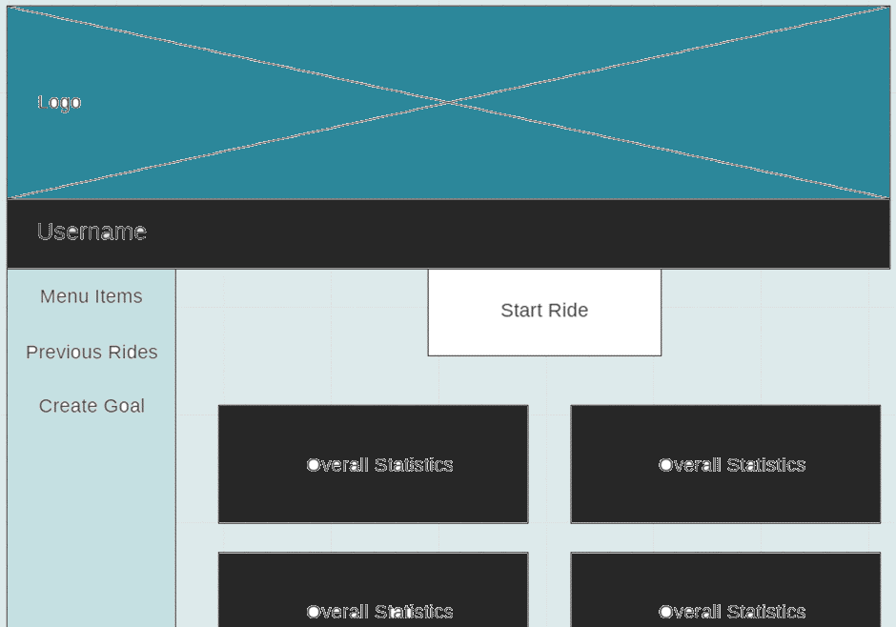
Option four was agreed upon by my family to be the best option and was a good design choice.

Work Plan

Iteration One
Goal: Since the model was incorrect from the previous assessment, the goal of the first iteration is to start to remake the model, by getting the data structures correct.
Task | Time Estimate | Time Taken | Product
Remake Class Diagram | 30min | 30min | Base Class Diagram
Layout code for classes | 30min | 30min | Class constructors laid out
Plan methods that will be required | 60min | 60min | Methods code laid out.
Get add functions working | 30min | 30min | Add functions pass unit tests
Get delete functions working | 30min | 60min | Delete functions pass unit tests
Create find trip function | 120min | 30min | Find trip successfully passes unit tests

Pseudocode

User:
Constructor:
  - Attributes created
Add Trip:
  - Create new Trip object
  - Update trip array
Delete Trip:
  - Find correct index in array from input
  - Delete trip object at correct index from array
Add Goal:
  - Find correct index in array from input
  - Create new goal object
  - Update goal array
Delete Goal:
  - Find correct index in array from input
  - Delete goal object at correct index from array
Set Trip to Completed
  - Set this trip object variable finished to true
Set Goal to Completed
  - Set this goal object variable finished to true
Find Trip
  - Search for correct index in array
  - Return value
Trip:
  - Constructor:
  - Attributes created
Goal:
  - Constructor:
  - Attributes created

Remake Class Diagram
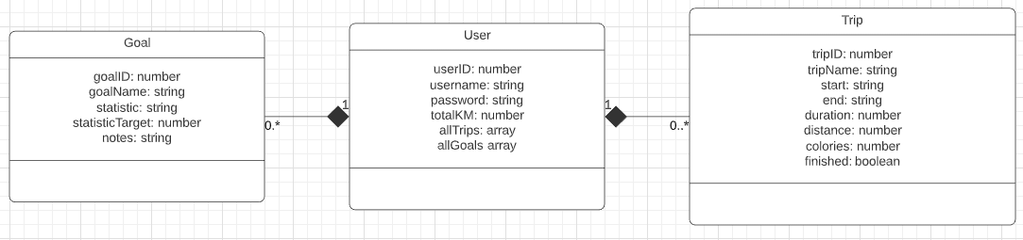

The class diagram above is to show what basic data structures will be in the model of the program. This is updated from the previous ones to meet the requirements. The user can have many goals and many trips.

Layout Code or Classes

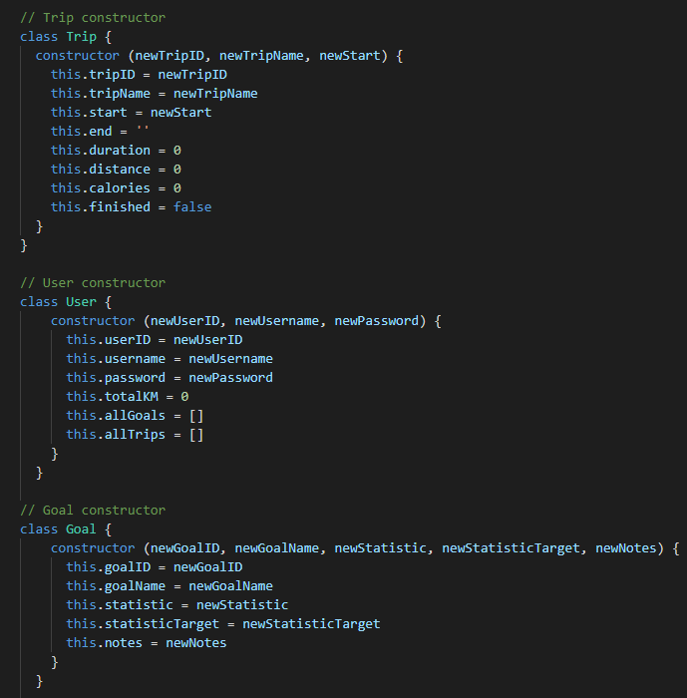

Plan Methods that will be Required

The class diagram below is expanding on this into the required methods to access and update the created goals and trips. I also added a completed variable to the goal class and changed the finished variable renaming it completed to keep naming same across the board.

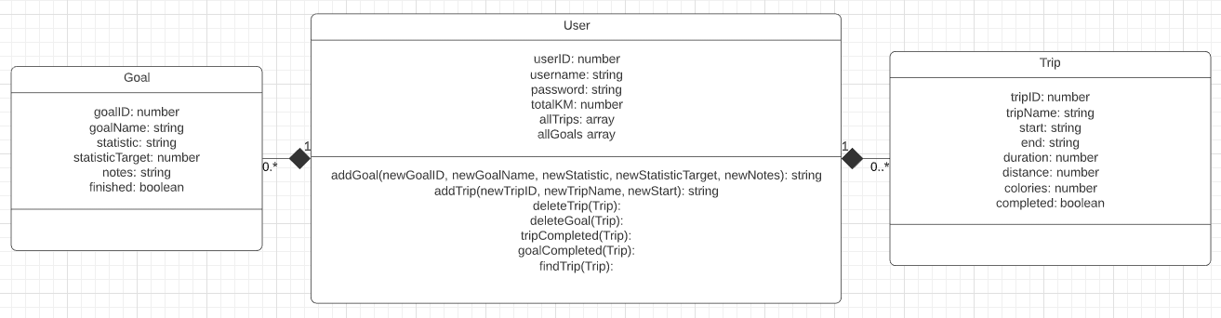
Get Add Functions Working

I will be using Jasmine to test my JavaScript. Here is the code for the tests. All tests can be found in the CycleAppSpec.js file in the directory spec in Iteration One. Tests passed with no test errors:
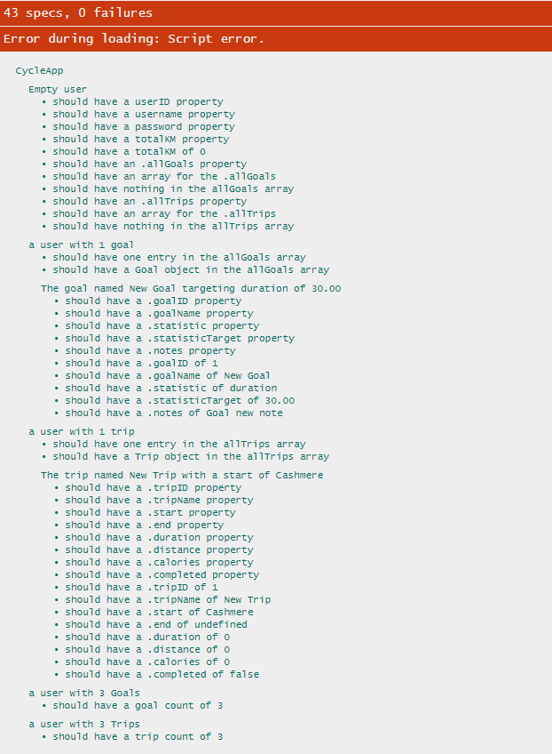

Get delete functions working

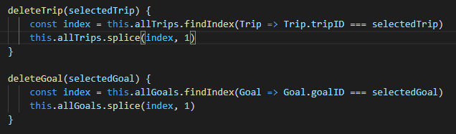
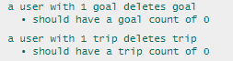

Create find trip function

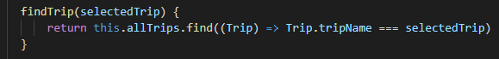
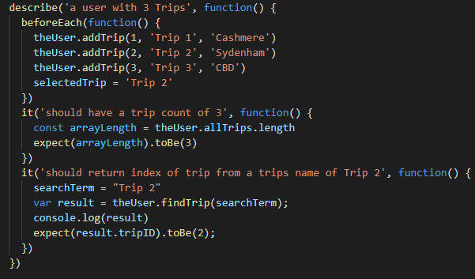

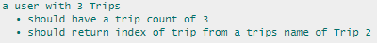

Evaluation

I thought about separating trip into two classes: route and trip. This would make sense later while creating a future where you can save and view routes separately. I want to keep it simpler for now and add this class when I am implementing the feature.
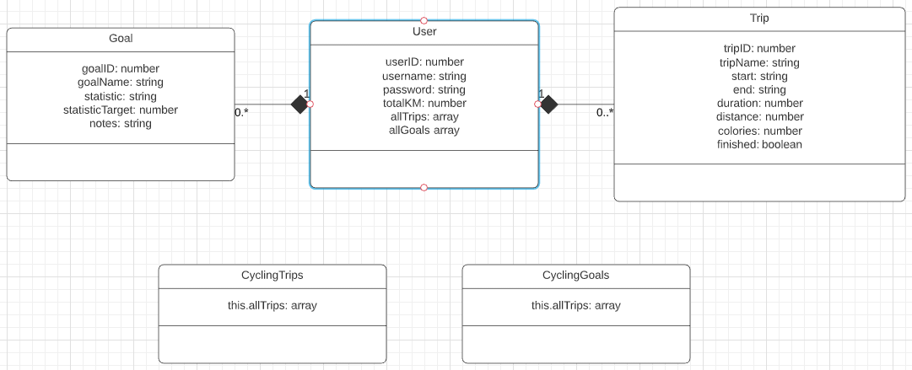
I thought about having all trips and all goals in separate classes as demonstrated in class. I wasn’t comfortable however implementing it this way as I have in the past kept these lists in the superclass, I think though this was causing me issues with being able to access these lists. I think I will try both.
I’m unsure whether using selected trip throughout many functions is a good idea n the long run as it may cause confusion/conflicts. Or whether it’s a good thing as it saved space. I’m assuming for now the user/the program will only be able to select one trip at a time so it should be fine, and it will be easy to simple change later if needed.

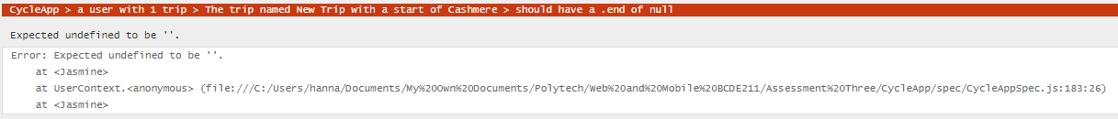
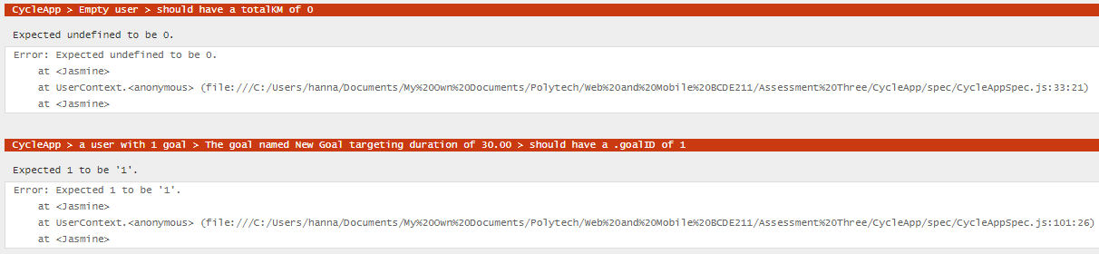
Initially I got a few failures in my jasmine testing. A few were solved by fixing typing errors. Something I learned is that if you set a variable to ‘’, i.e. a string with nothing in it, JavaScript sets that value to undefined:
After fixing these two issues, all tests went through:
However, there was an error in the script, which I was unsure about. I tried to find a solution but there seems to be no information online. I was also unsure how to debug it and without more information I decided to move on, as it didn’t seem to affect the tests passing at all.
I also want to note for future reference that while testing the delete functions, I tried to console log in a way where I would see the goal object created, then deleted next line. This however didn’t work, this was shown by the output.
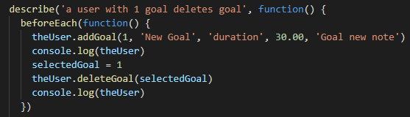
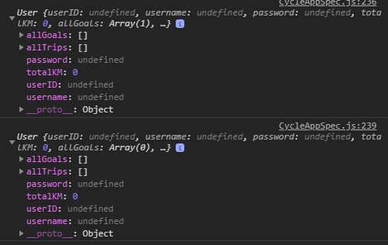
It seems for whatever reason Jasmine will not allow you to test in this way. I however know it works by commenting out the delete part of the test:
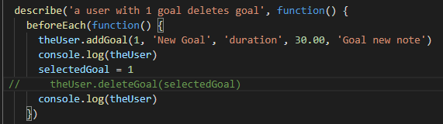
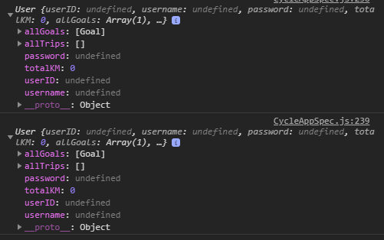
This shows that it is definitely being created beforehand. I’ll have to remember that I cannot manually test to make sure my Jasmine test is working correctly.
I think that I used good style practices with this code. All code is indented, I used short descriptive variable names, I avoided global variables, and I used the same coding style throughout the code.
I think that I did ok with this task. I think I could have been much faster if I had practiced more, and a beginner coder could have done this much faster. But I learnt a lot. This iteration fully meets the products required, all unit tests passed and the code functions.

Iteration Two
Goal: I want to get a responsive web app design in HTML and CSS working to display my app.
Task | Time Estimate | Time Taken | Product
Make wireframe with classes and grid layout | 30min | 30min | New wireframe
Code HTML | 30min | 30min | Base layout for website HTML
Code CSS Responsiveness | 60min | 120min | Fully responsive webpage on all devices
Code CSS for the look of the website | 60min | 60min | Completed CSS file
Run validators and fix errors | 30min | 30min | Validators pass with no errors

Make Wireframe with Classes and Grid Layout

I went over the previously made wireframes and planned out first how the grid would work, shown in yellow. For the mobile view it is very simple, with a single column, and the <main> element a two-column grid. The desktop view uses another grid for all elements except for the header, and a possible footer later on.
The elements of the website are shown in blue, with their element tags, as well as some notes.
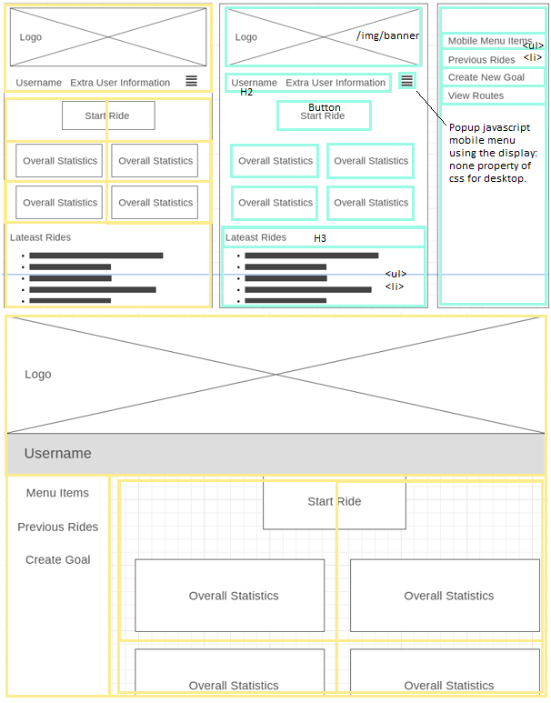

Code HTML

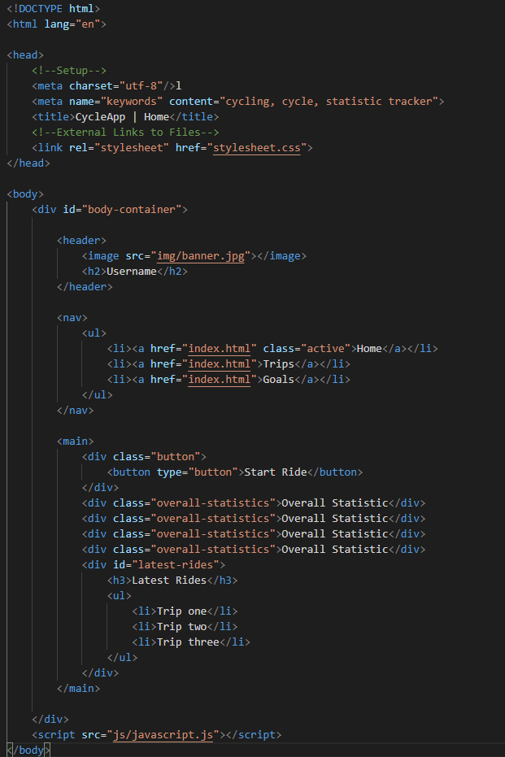

Code CSS Responsiveness

I started with the mobile view to make it display in a neat row, then worked upward from there. I added a mobile navigation temporarily until I implement a mobile menu later as an iteration.
All CSS can be found in the stylesheet.css file in the Iteration Two folder.

Code CSS for the look of the website

I used the established colour palate of green and blue to create the website. I added sufficient white space to make it easily readable as well.
The website can be viewed from the index.html in the Iteration Two folder.

Testing

I first used a HTML validator to validate my code against web standards.
https://validator.w3.org/

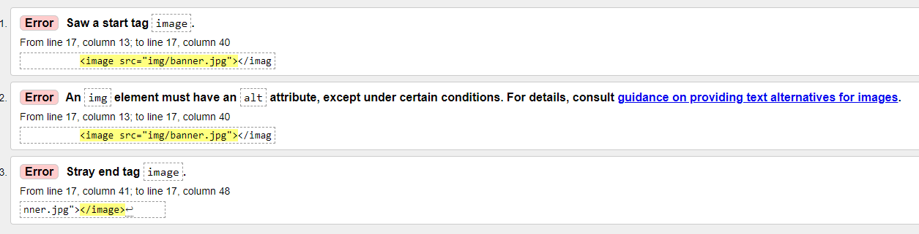
I then tested using a CSS validator
https://jigsaw.w3.org/css-validator/validator

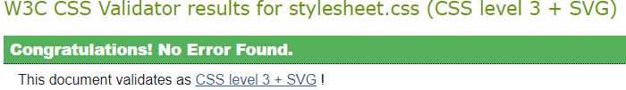

There were no errors found in the CSS, and all errors in the HTML were fixed by changing this line of code:
  - <image src="img/banner.jpg" alt="CycleApp Banner"></image>
To this line:
  - <img src="img/banner.jpg" alt="CycleApp Banner">

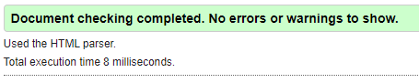
To check the responsiveness of the webpage I used Google Chromes inbuilt inspect tool at different screen widths.

Desktop
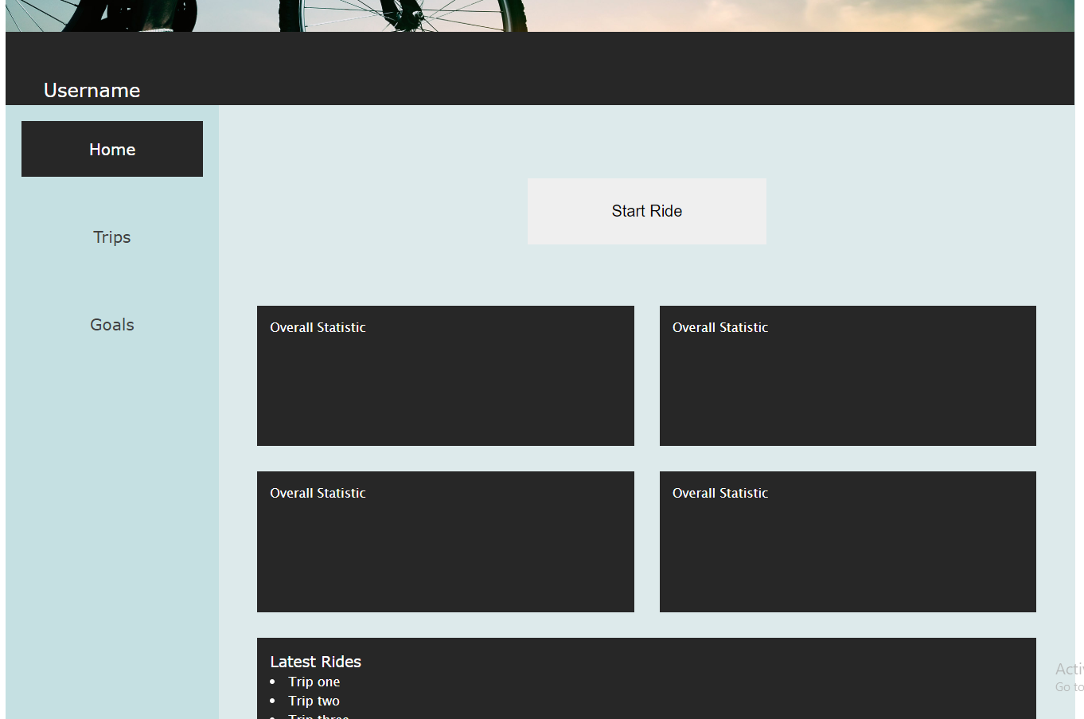

Tablet
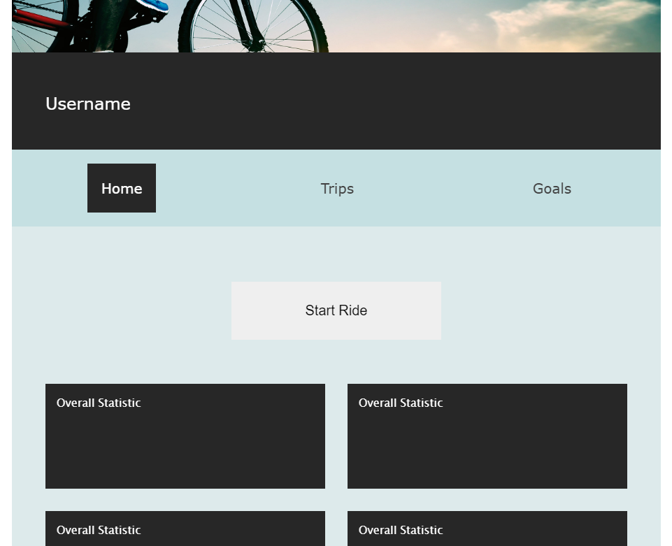

Mobile
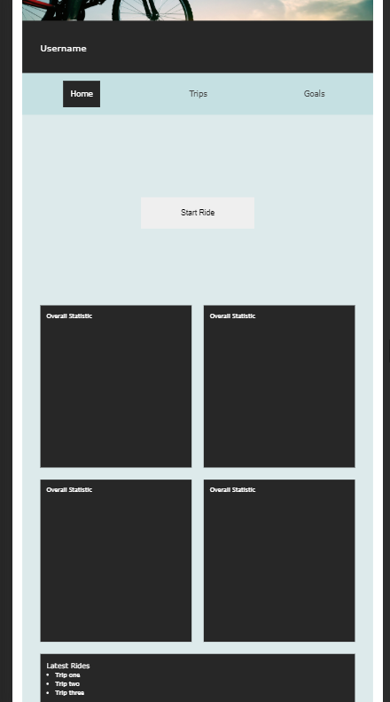

Evaluation

I made sure to include some css resets in my css file to make sure that the website will look the same no matter what browser it is shown in, as well as some other functionality I wanted.
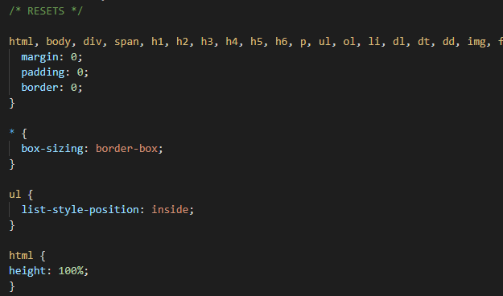
I also went with web-safe fonts, to make sure that the fonts for the page will be viewable no matter what browser the user is using.
I had decided on three sizes of layout, which is relatively standard, one for mobile, one for tablet, and one for desktop. However, this wasn’t that necessary I believe, since the change between the medium and the large layout was minimal.
I decided to put in the extra effort to make the website responsive in the end, since it is important for the users to be able to use the webpage on their phones, without loss of functionality or information.
I should remember to add alt attributes to help users with screen readers who may not be able to view the image, which follows web standards.
The site overall follows web standards and takes into account the contrast between important elements like the text and the background, keeping text large enough to meet standards, using web safe fonts etc.
I think I very accurately produced the wireframe and colour design I created earlier, it looks very similar. I’m very happy with my responsive design, and it works perfectly. I think I did this iteration quickly.

Iteration Three
Goal: I want to make the MVC pattern to display the trips on my webpage.
Task | Time Estimate | Time Taken | Product
Get output on webpage | 60min | 120min | Output displays on webpage of created trips
Format output | 30min | 30min | Output is formatted how I want it displayed
Do the same for goals class | 30min | 30min | Output is displayed formatted how I want
Add to HTML element | 30min | 30min | Displays in ride-list div

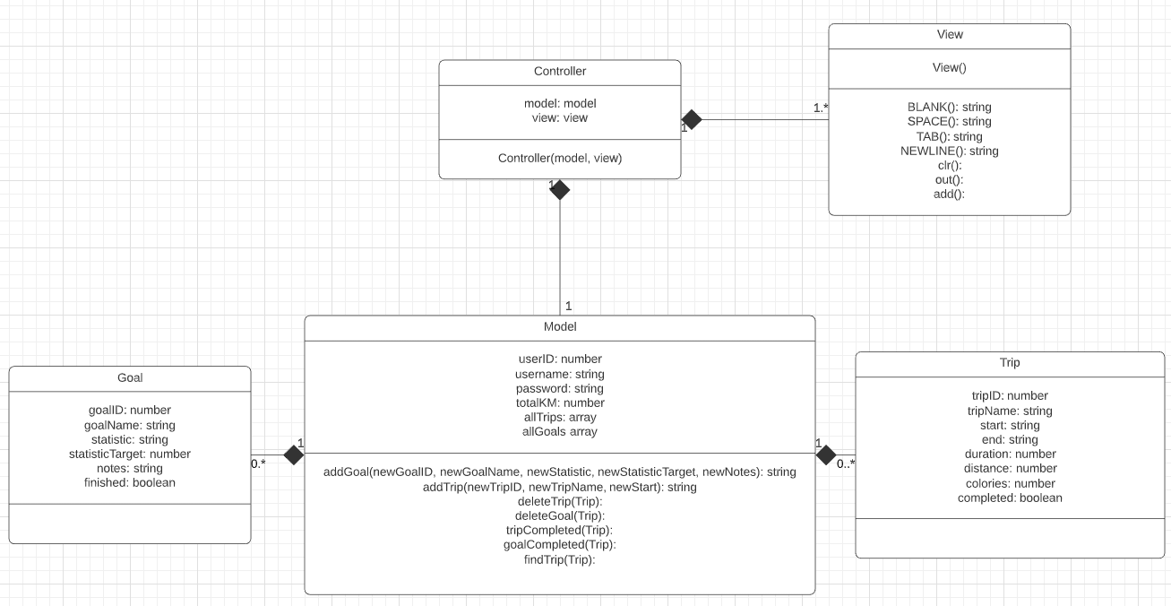

Pseudocode

Prerequisites:
A element for the output to display in with a tag to access it directly.
A toString to format the output in each class the correct way.
Controller:
  - Create new user object
  - Create goals and trips in new user object
  - Clear view if coming from different view
  - Call View function (pass through object)
View:
Function:
  - Update HTML of the element with (object)

Get Output on Webpage

Controller
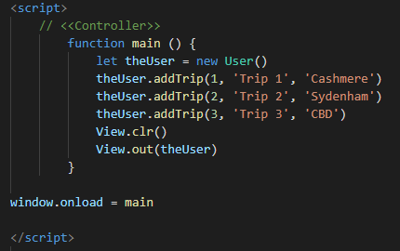
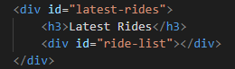

View
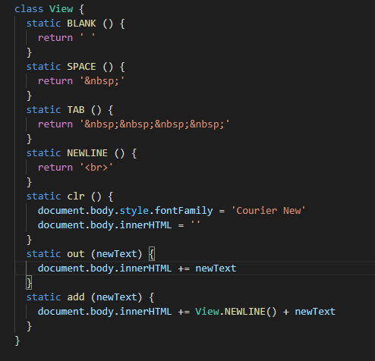

Output
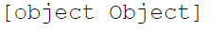

Formatted Output

I created a new trip and goal counting variable and caused the functions to update it.
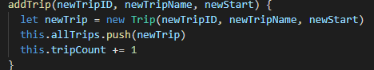
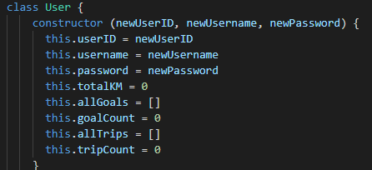

I added toString functions to my code.
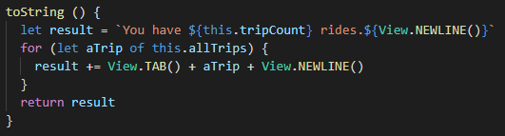

Output
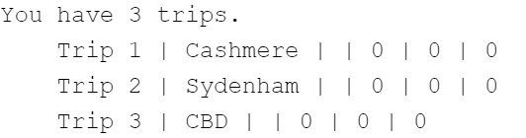

Do the Same for Goals Class

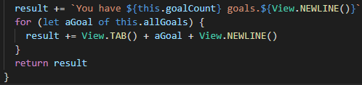
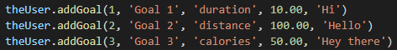

Output
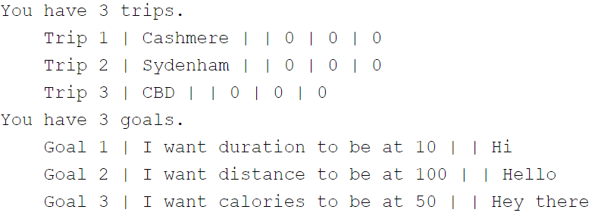

Add to HTML Element

Controller
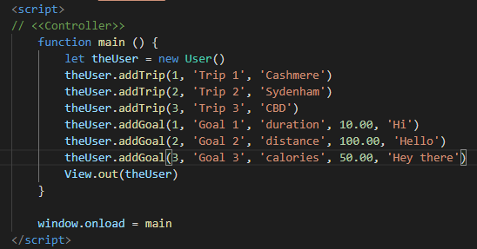

View
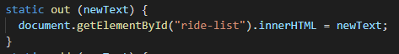

Output
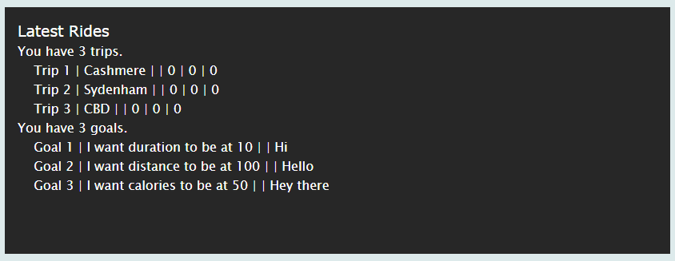

Evaluation

While trying to make it output to the correct element I used this:
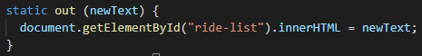
And got the error
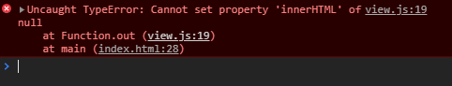
This meant that the code could not change the div element as it had not been created yet. This makes sense as HTML is read from top to bottom by the compiler. I should keep all code below the body element from now on unless necessary.
I got the correct output from my code, however I didn’t follow the class diagram exactly, and this is poor code design. I need to implement controller as a class in a later iteration to make it follow the correct structure. I did follow my pseudocode and my pseudocode was correct as well.
I took a longer then I expected to code this iteration, but I learnt a lot in the process.

Iteration Four
Goal: Convert to typescript
Task | Time Estimate | Time Taken | Product
Setup Typescript | 30min | 20min | Typescript and node is configured
Add variable parameters | 30min | 30min | Correct usage is used
Add function parameters | 30min | 30min | Output is displayed formatted how I want and code works

Convert model and view to typescript

All this was successful.

Add variable parameters

Here I used the typescript playground to create my code. My aim was to not get any errors, the only one I got was this, which I am unsure why:
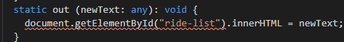

Add function parameters

All function perameters were added correctly. All code can be seen in CycleApp/js/typescript.ts
The app works as intended and the webpage looks the same.

Evaluation

I realised during conversion that one of my variables that I had used was named incorrectly, I named one ‘completed’ and another ‘finished. Visual Studio did not pick this up, but the Typescript playground did. I didn’t test this variable previously, I should have done so.
I got an error message while trying to convert:
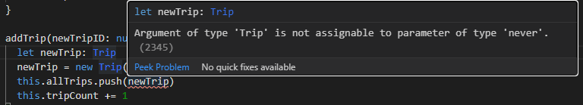
I found out that it was a separate issue and was caused by not declaring the arrays properly like this
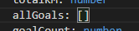
Instead of this
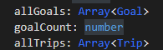
Which is correct. By working backwards from each time the variable was used going back to the constructor I was able to figure out the problem.
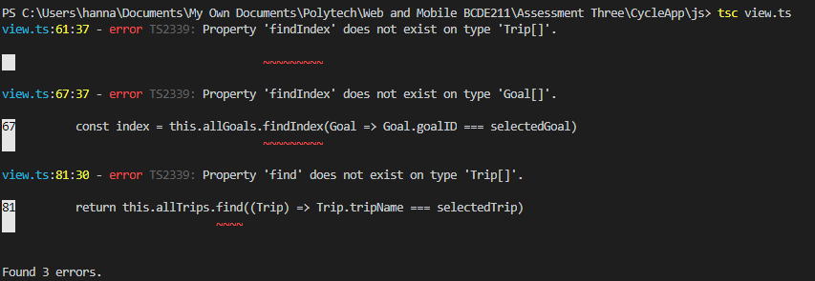
I got some errors to do with the arrays. However they are initialized correctly, and I could not find any more information on this issue:
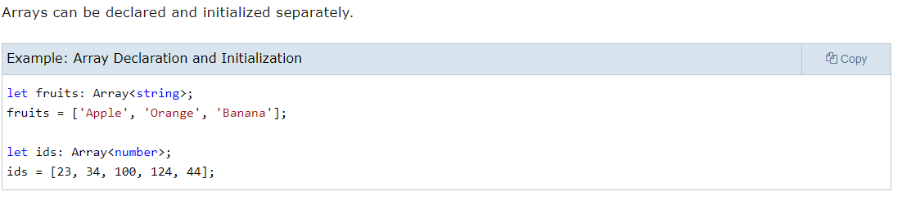
I assume that the error below is caused by the fact that the HTML is not in the same file as the Typescript, so Typescript cannot be sure whether the <div> that is being found has been created or not.
This iteration was too short really and I did not have enough time to fix the errors that appeared, but it was good to at least learn about typescript.
Overall, I haven’t met the requirements of my app, more iterations and time is required.

References

AlixStredwick. (2017, March 8). Why don't more women cycle? Retrieved from Cycling UK: https://www.cyclinguk.org/article/campaigns-guide/women-cycling#:~:text=Why%20don't%20more%20women%20cycle%3F,than%20four%20times%20as%20far.
Cycle Helmets. (n.d.). Mandatory bike helmet laws: Latest Reserch. Retrieved from Cycle Helmets: http://www.cycle-helmets.com/helmet_statistics.html
Perry, J. (2017, August 5). Cycling and gender: how and why male and female cyclists need to train differently. Retrieved from Cycling Weekly: https://www.cyclingweekly.com/fitness/cycling-and-gender-how-and-why-male-and-female-cyclists-need-to-train-differently-344365
https://developer.mozilla.org/en-US/docs/Web/JavaScript/A_re-introduction_to_JavaScript

